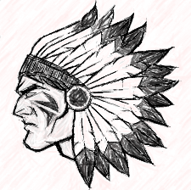
Havre de Grace Middle School
General School Supply List

- One large binder for all subjects (3 inch recommended)
- White wide-ruled, 3-ring notebook paper to last all year
- Dividers – 5 pack (total #)
- Pencil pouch
- Highlighters- 2 different colors
- Pencils
- Pens – dark blue or black ink only (No gel pens or permanent ink markers)
- Colored pencils
- Gym uniforms will cost $20.00 and can be purchased at Warrior Welcome and Open House for new students and during Physical Education classes when we return to school.
- 2-3 Spiral notebooks
- Post-its (different sizes)
- Optional Calculators are provided for classroom use by the school. However, should you want to purchase a calculator for home use, these are the recommended models.
  - Grade 6 4 Function Calculator
  - Grades 7-8 TI 83 or TI 84 Plus (Highly recommended for Algebra students)
- Optional Centimeter/ inch ruler & protractor are provided for classroom use by the school. However, some homework assignments will require these for home use.
- Optional Tissues – For all grades (optional, but strongly suggested)

Some teachers may require additional materials based on the needs of their classes.

